AI-BASED TIMETABLE GENERATION SYSTEM

DAY 1 – PROJECT TITLE FINALIZATION

Project Title
AI-Based Timetable Generation System

Project Overview
The AI-Based Timetable Generation System automates timetable creation for educational institutions. It helps schedule subjects, faculty, and classrooms without conflicts. The system reduces manual effort, improves scheduling efficiency, and ensures proper allocation of resources.

Outcome
- Project title finalized.
- Project scope identified.

DAY 2 – REQUIREMENT GATHERING

Problem Statement
Manual timetable preparation is time-consuming and may lead to scheduling conflicts. Educational institutions often face challenges in allocating faculty, classrooms, and subjects efficiently. The proposed system automates timetable generation and minimizes scheduling issues.

Requirements

Functional Requirements
- Login
- Faculty Management
- Subject Management
- Timetable Generation
- Timetable ViewingDAY 14 – LOGIN PAGE DEVELOPMENT
- Module Developed
- Login Module
- Features Implemented
- Username Input Field
- Password Input Field
- Login Button
- Form Validation
- Error Message Handling
- Technologies Used
- React.js
- HTML
- CSS
- JavaScript
- Outcome
- Login page successfully developed.
- User authentication interface completed.

Non-Functional Requirements
- Security
- Reliability
- User-Friendly Interface

Outcome
- Requirements document prepared.

DAY 3 – OBJECTIVE DEFINITION

Objectives
- Automate timetable generation.
- Reduce scheduling conflicts.
- Manage faculty and subjects efficiently.
- Improve timetable accuracy.
- Save administrative time.

Outcome
- Objectives finalized.

DAY 4 – USER & MODULE IDENTIFICATION

Users

Admin
- Manage faculty
- Manage subjects
- Generate timetable

User
- View timetable

Modules
- Login Module
- Faculty Module
- Subject Module
- Timetable Generation Module
- Timetable View Module

Outcome
- User roles and modules identified.

DAY 5 – USE CASE DIAGRAM PREPARATION

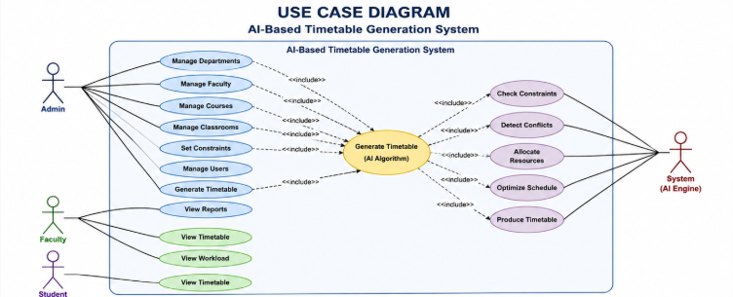

Use Cases

Admin
- Login
- Add Faculty
- Add Subject
- Generate Timetable

User
- View Timetable

Outcome
- Use Case Diagram completed.

DAY 6 – DATABASE REQUIREMENT ANALYSIS

Tables Required

Faculty
- Faculty_ID
- Faculty_Name

Subject
- Subject_ID
- Subject_Name

Classroom
- Room_ID
- Room_Name

Timetable
- Timetable_ID
- Day
- Time
- Faculty_ID
- Subject_ID

Outcome
- Database requirements analyzed.

DAY 7 – ER DIAGRAM DESIGN

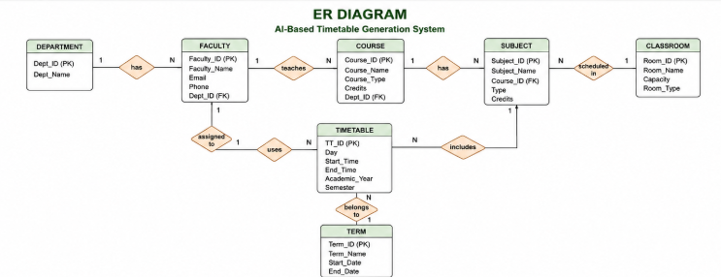

Entities
- Faculty
- Subject
- Classroom
- Timetable
- Department
- Course
- Term

Relationships
- Faculty teaches Subject.
- Subject assigned to Timetable.
- Classroom allocated for Timetable.

Outcome
- ER Diagram designed.

DAY 8 – DATABASE SCHEMA CREATION

Schema Design

Faculty Table
- Faculty_ID (PK)
- Faculty_Name

Subject Table
- Subject_ID (PK)
- Subject_Name

Classroom Table
- Room_ID (PK)
- Room_Name

Timetable Table
- Timetable_ID (PK)
- Faculty_ID (FK)
- Subject_ID (FK)
- Room_ID (FK)

Outcome
- Database schema completed.

DAY 9 – LOGIN PAGE DESIGN

Page 1: Login Page
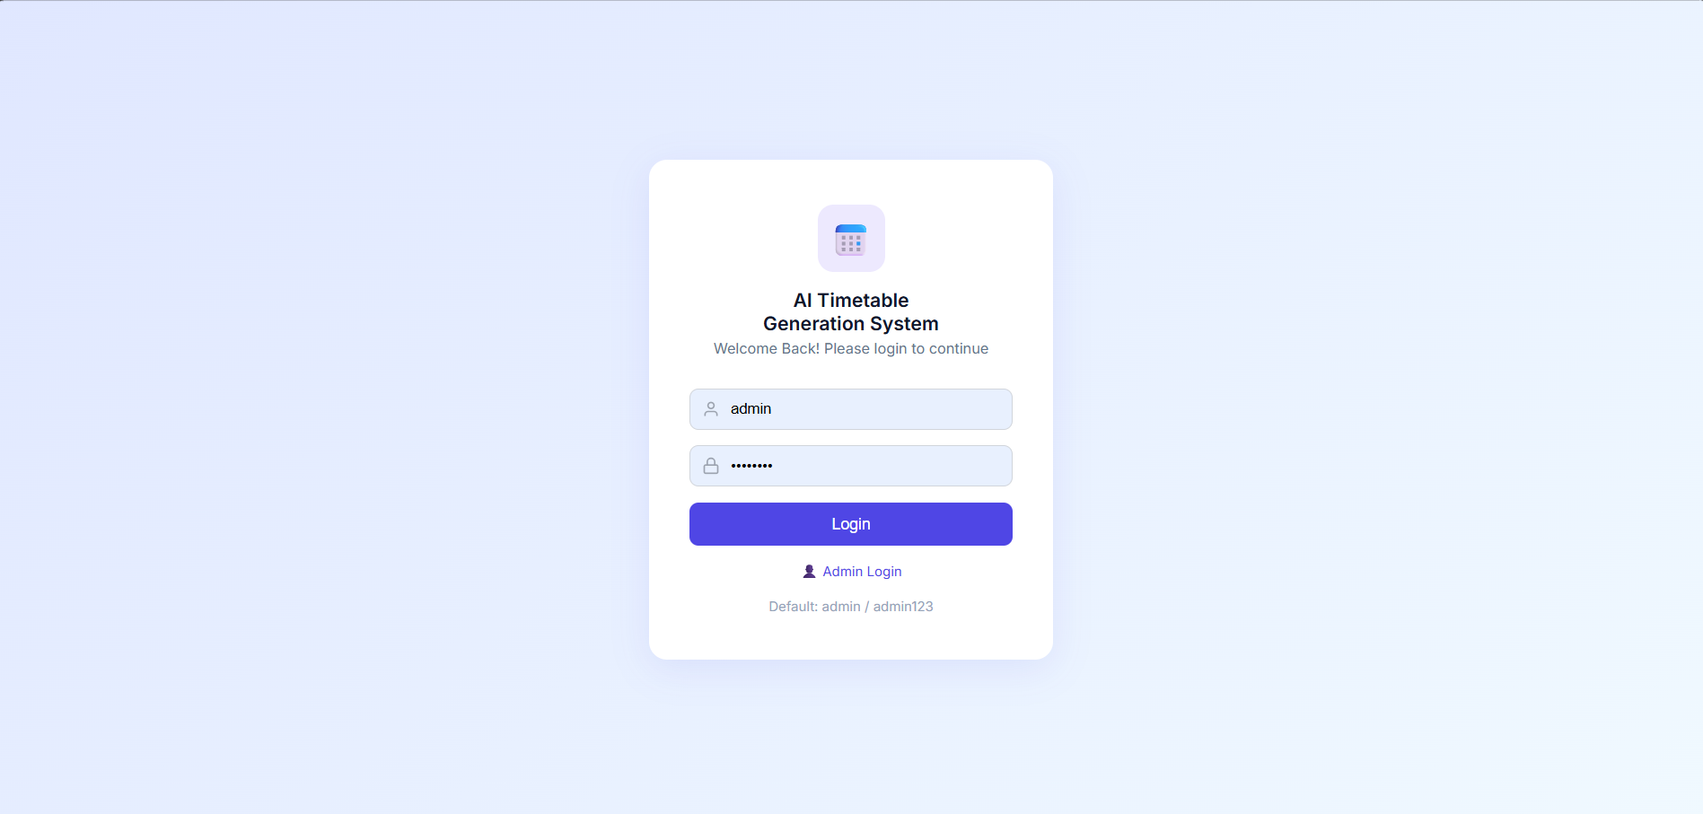

Components
- Username Textbox
- Password Textbox
- Login Button

Features
- User Authentication
- Input Validation

Outcome
- Login page wireframe prepared.

DAY 10 – DASHBOARD DESIGN

Page 2: Dashboard
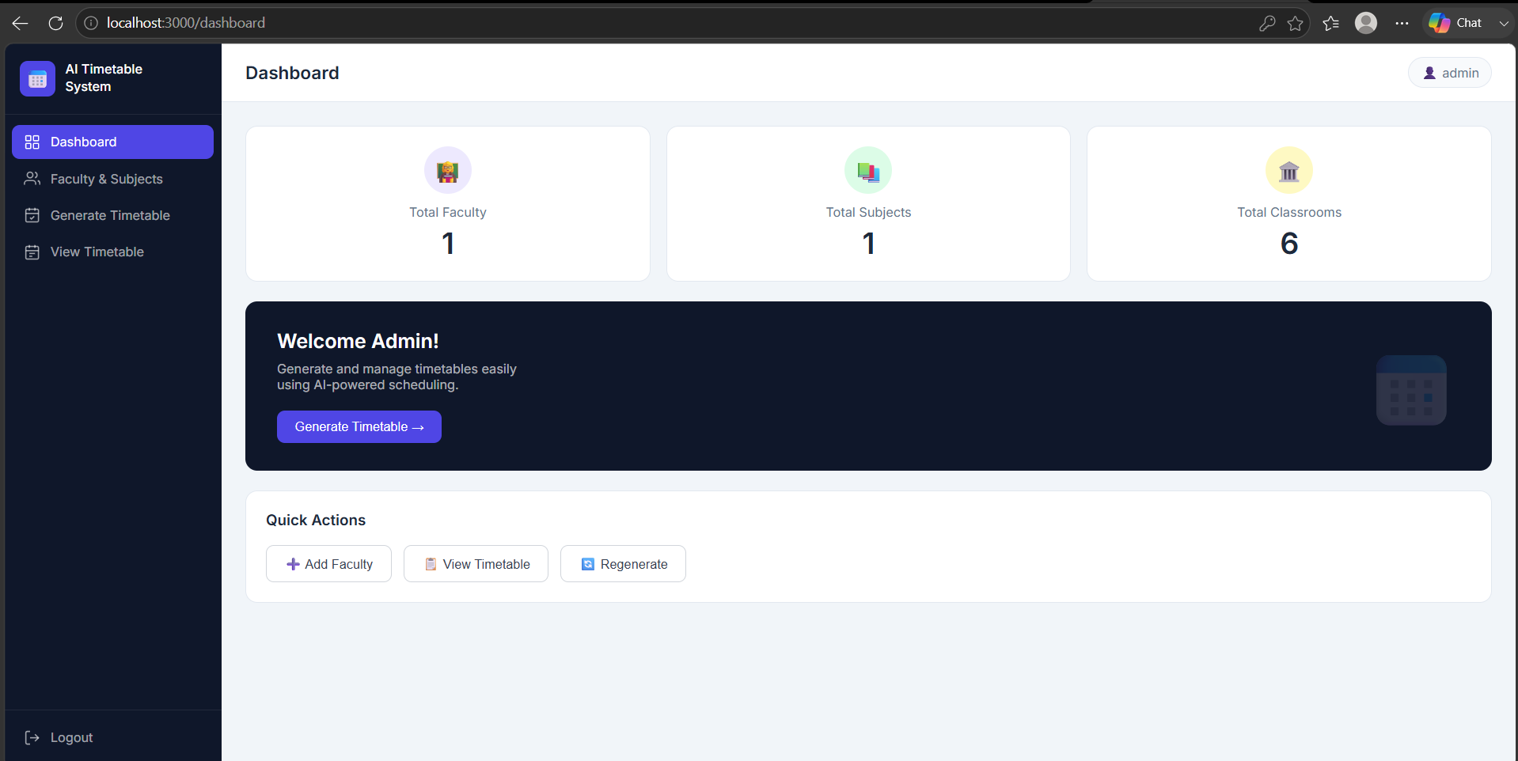

Components
- Total Faculty Count
- Total Subjects Count
- Generate Timetable Button
- Navigation Menu

Features
- Quick access to all modules
- Summary information display

Outcome
- Dashboard UI completed.

DAY 11 – FACULTY & SUBJECT MANAGEMENT PAGE

Page 3: Faculty and Subject Management
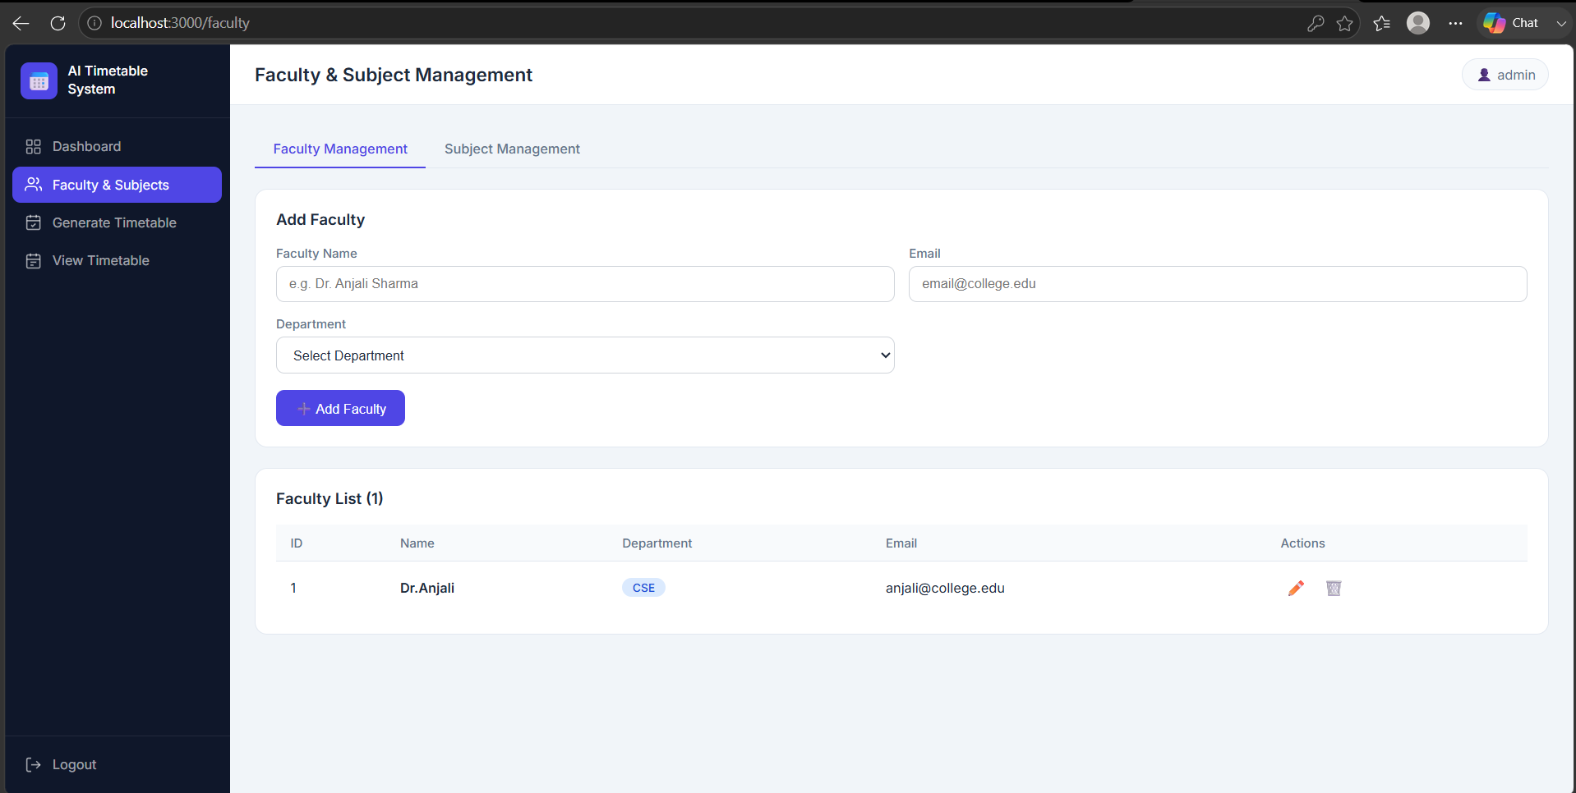

Faculty Section
- Add Faculty
- View Faculty

Subject Section
- Add Subject
- View Subject

Features
- Create, Read, Update and Delete (CRUD) operations

Outcome
- Management page designed.

DAY 12 – TIMETABLE GENERATION PAGE

Page 4: Generate Timetable
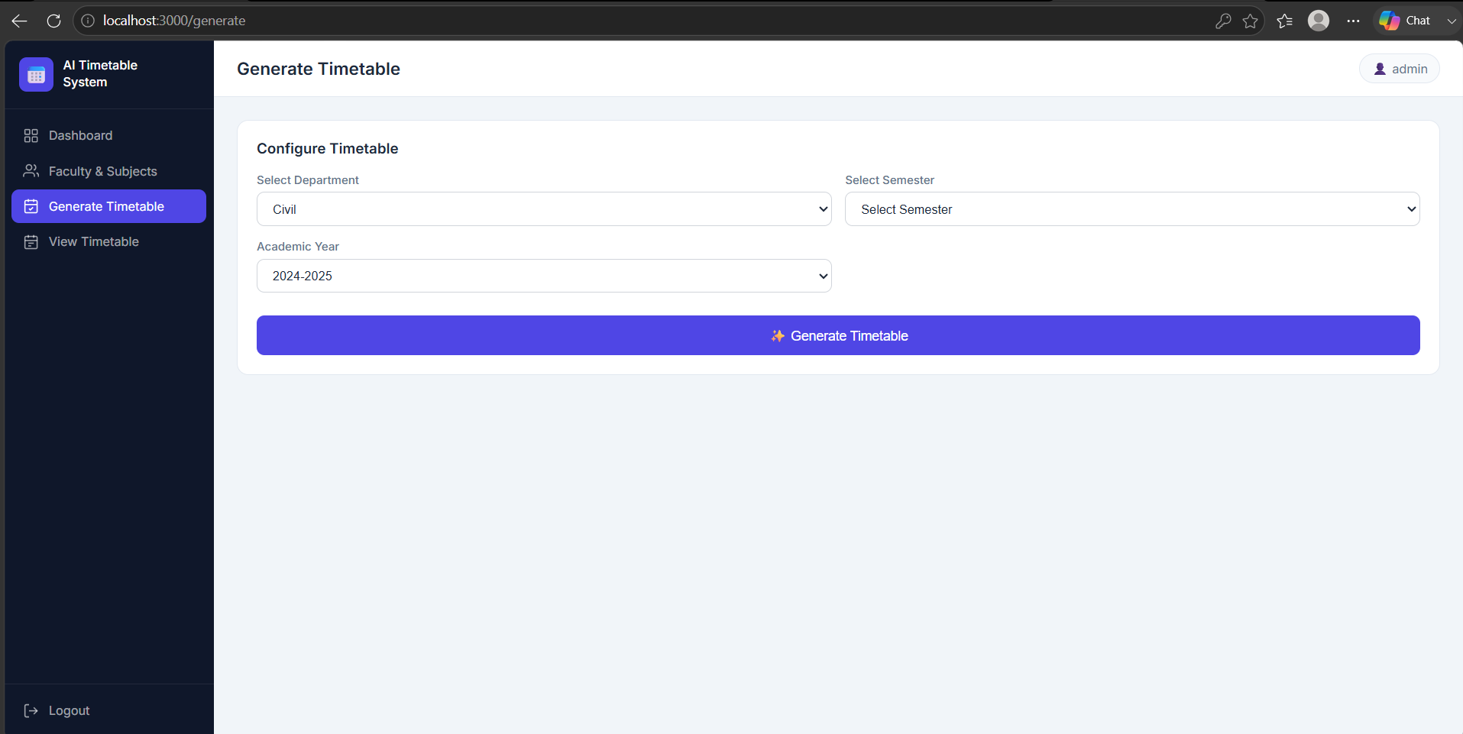

Components
- Select Department
- Select Semester
- Generate Button

Features
- Automatic timetable generation
- Conflict checking mechanism

Outcome
- Timetable generation page completed.

DAY 13 – TIMETABLE VIEW PAGE

Page 5: View Timetable
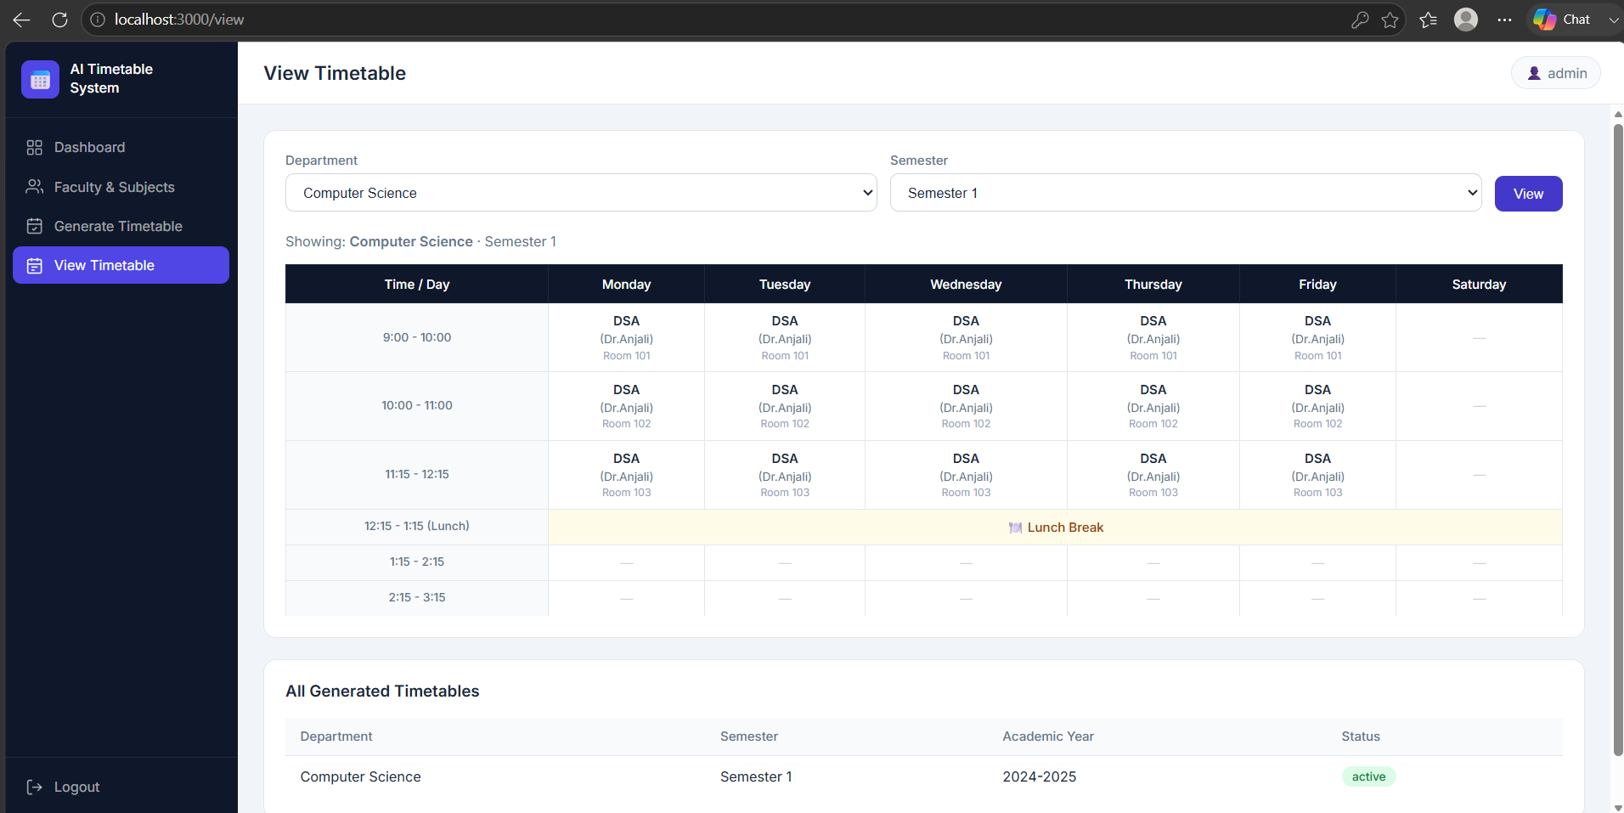

Components
- Timetable Table
- Day-wise Schedule
- Subject Details
- Faculty Details

Features
- Easy timetable viewing
- Organized schedule display

Outcome
- Timetable display page completed.

DAY 14 – LOGIN PAGE DEVELOPMENT

Module Developed
Login Module

Features Implemented
- Username Input Field
- Password Input Field
- Login Button
- Form Validation
- Error Message Handling

Technologies Used
- React.js
- HTML
- CSS
- JavaScript

Outcome
- Login page successfully developed.
- User authentication interface completed.

DAY 15 – REGISTRATION PAGE DEVELOPMENT

Module Developed
Registration Module

Features Implemented
- Faculty Registration Form
- User Registration Form
- Input Validation
- Data Submission

Fields Included
- Name
- Email
- Password
- Role

Outcome
- Registration page completed.
- New users can be registered into the system.

DAY 16 – DASHBOARD DEVELOPMENT

Module Developed
Dashboard UI

Features Implemented
- Faculty Count Display
- Subject Count Display
- Timetable Statistics
- Navigation Menu
- Quick Access Buttons

Technologies Used
- React Components
- CSS Styling

Outcome
- Dashboard interface completed.
- Centralized management panel created.

DAY 17 – CRUD FORM DEVELOPMENT

Modules Developed
1. Faculty Management
2. Subject Management

CRUD Operations

Faculty
- Add Faculty
- View Faculty
- Update Faculty
- Delete Faculty

Subject
- Add Subject
- View Subject
- Update Subject
- Delete Subject

Outcome
- CRUD forms completed.
- Data management functionality implemented.

DAY 18 – TABLE & SEARCH FEATURES

Features Implemented
- Faculty Data Table
- Subject Data Table
- Search Functionality
- Filter Records
- Pagination Support

Benefits
- Easy record management
- Faster data retrieval

Outcome
- Data listing pages completed.
- Search functionality integrated.

DAY 19 – FRONTEND TESTING

Testing Performed
- Login Page Testing
- Registration Page Testing
- Dashboard Testing
- CRUD Form Testing
- Search Functionality Testing

Issues Fixed
- Input Validation Errors
- Navigation Issues
- UI Alignment Problems

Outcome
- Frontend reviewed and tested successfully.
- User interface stabilized.

DAY 20 – SPRING BOOT PROJECT SETUP

Backend Environment Setup

Technologies Configured
- Java
- Spring Boot
- Maven
- MySQL
- Spring Web

Dependencies Added
- Spring Boot Starter Web
- Spring Boot Starter Data JPA
- MySQL Connector
- Lombok

Outcome
- Backend project structure created.
- Spring Boot environment configured successfully.

DAY 21 – DATABASE CONNECTIVITY

Database Configuration

Setup Completed
- MySQL Database Creation
- Application Properties Configuration
- JDBC Connection Setup
- Database Testing

Configuration Details
- Database URL configured
- Username and Password configured
- Connection verified successfully

Outcome
- Database connected successfully.
- Backend communication with database established.

DAY 22 – ENTITY & REPOSITORY CREATION

Entities Created

Faculty Entity
- facultyId
- facultyName

Subject Entity
- subjectId
- subjectName

Classroom Entity
- roomId
- roomName

Timetable Entity
- timetableId
- day
- timeSlot

Repository Interfaces Created
- FacultyRepository
- SubjectRepository
- ClassroomRepository
- TimetableRepository

Technologies Used
- Spring Data JPA
- Hibernate

Outcome
- Entity classes created.
- Repository layer completed.

DAY 23 – REST API DEVELOPMENT

APIs Developed

Authentication APIs
- Login API
- Registration API

Faculty APIs
- Add Faculty
- Get Faculty
- Update Faculty
- Delete Faculty

Subject APIs
- Add Subject
- Get Subject
- Update Subject
- Delete Subject

Timetable APIs
- Generate Timetable
- View Timetable

HTTP Methods Used
- GET
- POST
- PUT
- DELETE

Outcome
- REST APIs successfully developed.
- Frontend and backend integration ready.

DAY 24 – AUTHENTICATION MODULE

Module Developed
Authentication Module

Features Implemented
- User Login Authentication
- Password Validation
- Session Management
- Role-Based Access (Admin/User)
- Unauthorized Access Prevention

Technologies Used
- Spring Security
- Spring Boot
- JWT (or Session-Based Authentication)
- React.js

Outcome
- Secure authentication module completed.
- Only authorized users can access the system.

DAY 25 – BACKEND BUSINESS LOGIC

Module Developed
Business Logic Layer (Service Layer)

Features Implemented
- Faculty Management Logic
- Subject Management Logic
- Timetable Generation Logic
- Input Validation
- Exception Handling

Technologies Used
- Spring Boot
- Service Classes
- Java Collections

Outcome
- Business logic implemented successfully.
- Backend services connected with repositories.

DAY 26 – API TESTING USING POSTMAN

Testing Tool
Postman

APIs Tested
- Login API
- Registration API
- Faculty CRUD APIs
- Subject CRUD APIs
- Generate Timetable API
- View Timetable API

Testing Performed
- GET Requests
- POST Requests
- PUT Requests
- DELETE Requests
- Response Validation
- Error Handling

Outcome
- All APIs tested successfully.
- API testing report prepared.

DAY 27 – FRONTEND & BACKEND INTEGRATION

Integration Completed
- React Frontend connected with Spring Boot Backend
- REST APIs integrated
- Database connected with frontend
- Dynamic data loading implemented

Modules Integrated
- Login Module
- Faculty Module
- Subject Module
- Timetable Generation Module
- Timetable View Module

Outcome
- Complete application working successfully.
- Frontend and backend integrated.

DAY 28 – BUG FIXING & VALIDATION

Testing Performed
- Functional Testing
- Form Validation
- API Validation
- UI Validation
- Database Validation

Bugs Fixed
- Login Issues
- CRUD Operation Errors
- API Response Errors
- UI Alignment Issues
- Data Validation Errors

Outcome
- Major bugs resolved.
- System performance improved.

DAY 29 – DOCUMENTATION & PPT PREPARATION

Documentation Prepared
- Project Report
- Daily Work Log
- SRS Document
- ER Diagram
- Use Case Diagram
- Database Schema
- API Documentation

Presentation Prepared
- Project Introduction
- Problem Statement
- Objectives
- Technologies Used
- System Architecture
- Modules
- Results
- Future Enhancements

Outcome
- Project report completed.
- Presentation (PPT) prepared for final demonstration.

